Linux Basics and Command Line
K Naveen Kumar
Introduction to Linux:
Overview
Linux is a powerful, open-source operating system used across a wide range of computing environments including personal computers, servers, cloud infrastructure, and embedded systems. An operating system acts as the core software that manages hardware resources and provides services for applications. Linux is known for its stability, security, flexibility, and community-driven development.
The system was created in 1991 by Linus Torvalds while studying computer science at the University of Helsinki. What started as a personal project soon grew into a global collaborative effort, attracting developers from around the world who contributed to improving the system.
What is Linux
Linux is technically a kernel, which is the core component of an operating system responsible for managing system resources. The kernel controls interactions between hardware and software by managing processes, memory, input/output operations, and device communication.
When the Linux kernel is combined with system utilities, libraries, and applications, it forms a complete operating system commonly referred to as GNU/Linux.
Key Characteristics of Linux
Open Source
Linux is distributed under an open-source license, meaning its source code is freely available. Developers can study, modify, and redistribute the code, which encourages innovation and collaboration.
Stability and Reliability
Linux systems are widely recognized for their ability to run continuously without crashes or performance degradation. This makes Linux a preferred choice for servers and enterprise systems.
Security
Linux includes strong permission systems and user controls that help protect the system from unauthorized access and malware.
Flexibility
Linux can run on a wide variety of hardware, from small embedded devices to large supercomputers. Its modular design allows users to customize the system according to their needs.
Where Linux is Used
Linux plays a critical role in modern computing infrastructure. It powers many of the systems that support the internet and digital services used daily.
Common areas where Linux is used include:
• Web servers and cloud computing platforms
• Enterprise IT infrastructure
• Mobile operating systems
• Embedded systems and IoT devices
• Supercomputers and research environments
Many well-known Linux distributions such as Ubuntu, Fedora, and Debian provide user-friendly environments for developers and system administrators.
Importance of Learning Linux
Learning Linux is an essential skill for professionals working in modern technology environments. Many industries rely on Linux for managing infrastructure, deploying applications, and maintaining secure systems.
Knowledge of Linux is particularly valuable for careers in:
• System Administration
• Cloud Computing
• DevOps Engineering
• Cybersecurity
• Software Development
Because Linux dominates the server and cloud ecosystem, understanding its commands, file system, and architecture provides a strong foundation for many technical roles.
Linux History and Philosophy
Background
The history of Linux is closely related to the development of open-source software. In the early years of computing, most operating systems were proprietary, meaning their source code was controlled by companies and not freely available to users. This limited collaboration and innovation among developers.
In the 1980s, a movement promoting free and open software began to grow. A key figure in this movement was Richard Stallman, who started the GNU Project with the goal of creating a free operating system that anyone could use, modify, and distribute.
The missing piece of this system was a kernel. In 1991, Linus Torvalds developed the Linux kernel and shared it publicly. When the Linux kernel was combined with GNU tools and utilities, it formed the complete operating system known as GNU/Linux.
Philosophy of Linux
The philosophy behind Linux is based on the principles of openness, collaboration, and freedom.
Open Source Development
Linux allows users to access and modify its source code. This encourages innovation and continuous improvement by developers worldwide.
Community Collaboration
Thousands of programmers and organizations contribute to Linux development, making it one of the largest collaborative software projects.
Freedom and Flexibility
Users are free to use, modify, and distribute Linux according to their needs, which has helped it become widely adopted in many industries.

Importance
Because of its open and collaborative philosophy, Linux has become a foundation for modern technology. It is widely used in servers, cloud computing, and large-scale computing systems.
Origins of Linux and GNU/Linux
Development of Linux
The origin of Linux dates back to 1991 when Linus Torvalds, a computer science student at the University of Helsinki, began developing a new operating system kernel as a personal project. His goal was to create a system that could take advantage of the capabilities of personal computers while remaining free and accessible to developers.
Linus released the Linux kernel on the internet and invited programmers around the world to contribute to its development. This open collaboration helped improve the system rapidly and led to the creation of a powerful and stable operating system.
Role of the GNU Project
Before Linux was created, the GNU Project had already developed many essential software tools such as compilers, editors, and libraries needed for an operating system. The project was started by Richard Stallman with the aim of building a completely free operating system.
However, the GNU Project did not yet have a working kernel. When the Linux kernel became available, it was combined with the GNU tools to form a complete operating system.
GNU/Linux System
The combination of the Linux kernel and GNU utilities created the operating system commonly known as GNU/Linux. This system provides the core functionality needed to manage hardware resources, run applications, and support users.
Over time, many Linux-based operating systems known as distributions were developed. Popular examples include Ubuntu, Fedora, and Debian. These distributions package the Linux kernel with additional software, tools, and graphical interfaces to make the system easier to use.

Open Source Movement
Overview
The Open Source Movement promotes the idea that software source code should be freely available so that anyone can study, modify, and improve it. This approach encourages collaboration among developers and allows software to evolve through contributions from a global community.
The concept gained popularity through the efforts of the Open Source Initiative, which works to promote and protect open-source software. The movement focuses on transparency, shared knowledge, and community-driven development.
Key Principles
Free Access to Source Code
Users can view and understand how the software works.
Freedom to Modify
Developers are allowed to improve the software and adapt it for different purposes.
Collaboration
Programmers from around the world contribute to improving the software.
Redistribution
Users can share the software with others, helping technology spread faster.
Importance
The Open Source Movement has had a major impact on modern technology. Many widely used systems and platforms are based on open-source software, including the Linux operating system and many web technologies.
Popular Linux Distributions
Overview
A Linux distribution (often called a Linux distro) is a complete operating system built using the Linux kernel along with system tools, libraries, and applications. Different distributions are created to meet various user needs such as personal computing, software development, servers, and enterprise environments.
Each distribution includes the Linux kernel, package management systems, and additional software that make the operating system easier to install and use.

Common Linux Distributions
Ubuntu
Ubuntu is one of the most popular and beginner-friendly Linux distributions. It provides a simple interface, strong community support, and regular updates, making it widely used for learning Linux and desktop computing.
Fedora
Fedora is a modern Linux distribution known for using the latest technologies and features. It is commonly used by developers and advanced users who want access to new software innovations.
Debian
Debian is known for its stability and reliability. Many other distributions are built on Debian, and it is widely used in servers and long-term system deployments.
CentOS
CentOS was traditionally used in enterprise environments because it was compatible with enterprise Linux systems and offered a stable platform for servers.
Importance
Linux distributions make it easier for users to install and manage Linux systems. They provide different environments and tools depending on the purpose, such as desktop usage, server management, or development.
Understanding Desktop Environments
Introduction
A Desktop Environment (DE) in Linux provides the graphical user interface (GUI) that allows users to interact with the operating system visually. It includes elements such as windows, icons, menus, panels, file managers, and system settings. Desktop environments make it easier for users to operate the system without relying entirely on command-line instructions.
In Linux, desktop environments are flexible and customizable. Unlike some operating systems where the interface is fixed, Linux allows users to choose and install different desktop environments according to their preferences and system requirements.
Main Components of a Desktop Environment
A desktop environment usually consists of several components that work together to provide a complete graphical interface.
Window Manager
Controls the appearance and behavior of windows, including moving, resizing, and closing application windows.
File Manager
Allows users to browse files and folders, manage documents, and organize data within the system.
Panels and Menus
Provide quick access to applications, system settings, and running programs.
System Tools and Utilities
Include settings managers, application launchers, and system configuration tools that help users control the operating system.
Popular Linux Desktop Environments
GNOME
GNOME is one of the most widely used desktop environments in Linux. It focuses on simplicity, clean design, and ease of use. GNOME provides a modern interface and is the default desktop environment in several Linux distributions such as Ubuntu.
Features
- Simple and modern interface
- Integrated system settings and applications
- Focus on productivity and usability
KDE Plasma
KDE Plasma is known for its powerful customization options and visually appealing design. It allows users to modify almost every part of the desktop environment, including themes, layouts, and system behavior.
Features
- Highly customizable interface
- Advanced features and widgets
- Modern and visually rich design
XFCE
XFCE is a lightweight desktop environment designed to run efficiently on systems with limited hardware resources. It provides a simple and fast interface while still offering essential desktop features.
Features
- Lightweight and fast performance
- Low system resource usage
- Suitable for older computers and minimal setups
Importance
Desktop environments improve user experience by providing an intuitive graphical interface. They allow users to easily manage files, launch applications, and configure system settings without needing advanced technical knowledge.

Command Line Basics
Introduction
The command line in Linux allows users to interact with the operating system by typing commands in the terminal. It provides a powerful way to manage files, directories, and system operations quickly and efficiently. Many system administration tasks are performed using command-line tools.
The terminal is a program that allows users to access the command-line interface of the Linux system.
Accessing the Terminal
Method 1 – Keyboard Shortcut
Press:
Ctrl + Alt + T
This opens the terminal window.
Method 2 – Application Menu
- Open the applications menu
- Search for Terminal
- Click the Terminal icon
Basic Navigation Commands
1) pwd Command
Purpose
Displays the current working directory.
Explanation
This command shows the exact path of the directory you are currently working in.
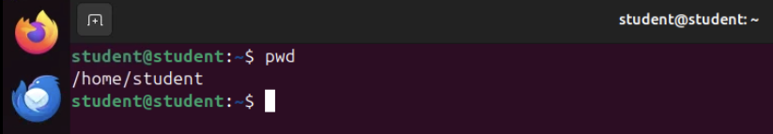
2. ls Command
Purpose
Lists the files and directories in the current folder.

Explanation
This command shows all files and folders inside the current directory.
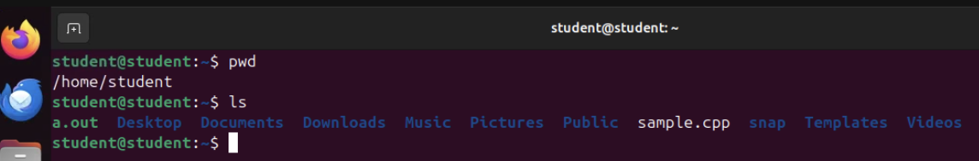

3. ls -l Command
Purpose
Displays files with detailed information.
Explanation
Shows additional details such as:
- File permissions
- Owner name
- File size
- Date modified
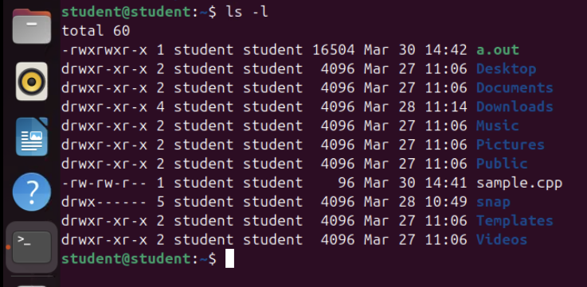

4. ls -a Command
Purpose
Shows all files including hidden files.
Explanation
Hidden files in Linux start with a dot (.).
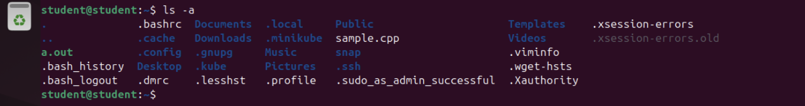
5. cd Command
Purpose
Used to change the current directory.
Explanation
Moves the user into the Documents directory.
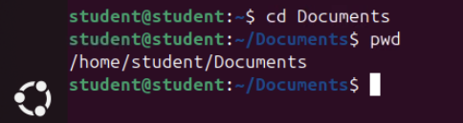
6. cd .. Command
Purpose
Moves one directory back.
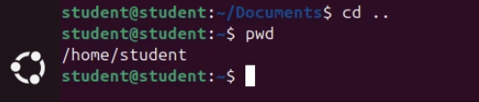

7. mkdir Command
Purpose
The mkdir (make directory) command is used to create a new directory (folder) in Linux. It helps organize files by grouping them into directories.
What Happens
A new folder named project will be created in the current directory.
8. touch Command
Purpose
The touch command is used to create empty files. It can also update the timestamp of an existing file.

9. cat Command
Purpose
The cat (concatenate) command is used to display the contents of a file.
Add text to a file and then by using cat we diplay the content in file.
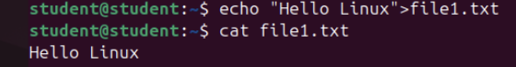
Creating File Using cat
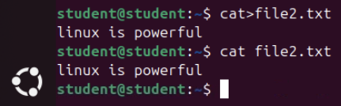
10. cp Command
Purpose
The cp (copy) command is used to copy files or directories.
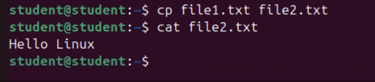
11. mv Command
Purpose
The mv (move) command is used to move or rename files.
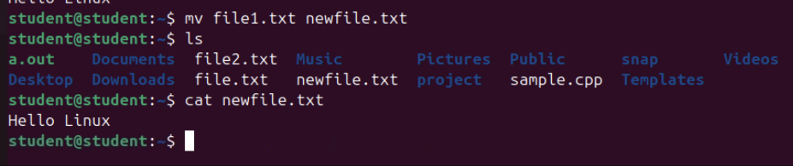
12. rm Command
Purpose
The rm (remove) command deletes files or directories.
careful — deleted files cannot be recovered easily.
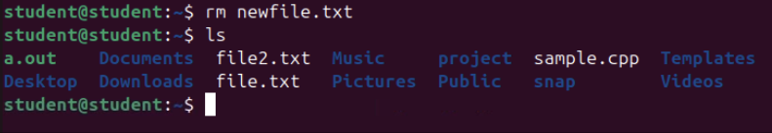

13. rmdir Command
Purpose

The rmdir command removes empty directories only.
14. date Command in Linux
The date command is used to display the current system date and time. It can also be used to format the date in different ways.
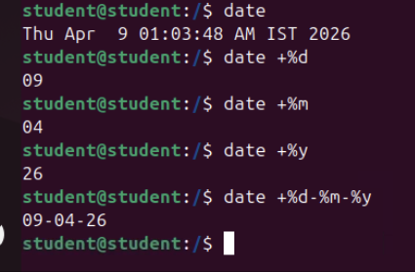

Directory Structure in Linux
Linux follows a hierarchical directory structure, which means all files and directories are organized in a tree-like format starting from a single root directory. Every file in the Linux system is stored somewhere within this structure.
Understanding the directory structure helps users locate system files, manage applications, and organize personal data efficiently.
The top level of the Linux file system is called the Root Directory.
Root Directory (/)
The root directory is represented by /. It is the starting point of the entire Linux file system. All other directories and files exist under this directory.
Example command to view the root directory:
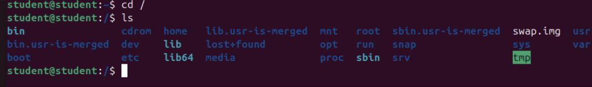
Home Directory (/home)
The home directory stores personal files for each user. Every user in Linux has a separate home directory where they can save documents, downloads, and other personal data.
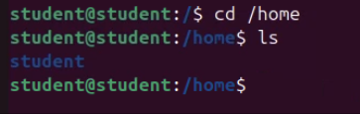
Bin Directory (/bin)
The /bin directory contains essential command binaries required for basic system operations. Many common Linux commands are stored here.
Examples of commands located in /bin include:
- ls
- cp
- mv
- cat
- echo
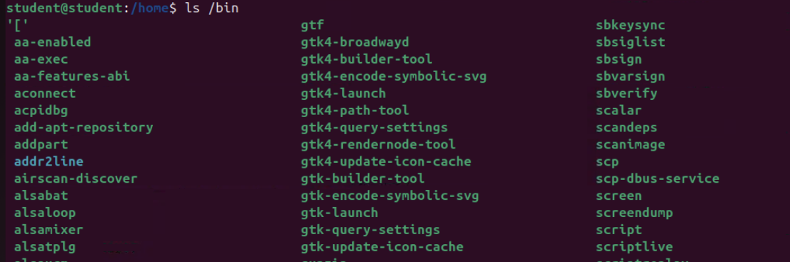

/etc
The /etc directory contains system configuration files used by the operating system and applications.
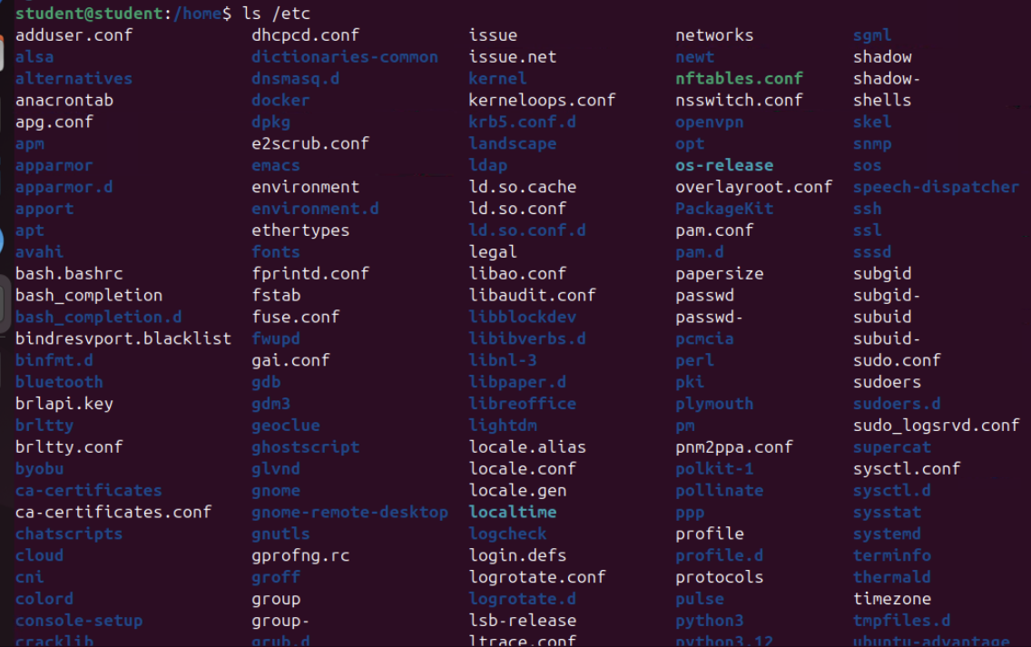

/var
The /var directory stores variable data such as logs, cache files, and temporary files created during system operation.
/tmp
The /tmp directory is used for storing temporary files created by programs or users. Files in this directory are usually deleted automatically after system reboot.
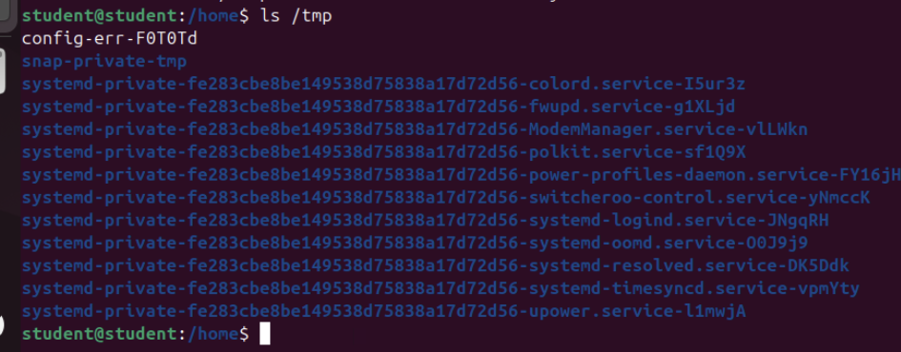
/usr
The /usr directory contains user-installed applications, libraries, and documentation. Many software programs installed on the system are stored here.
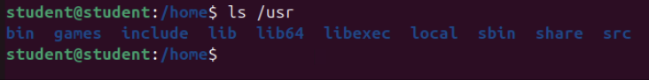

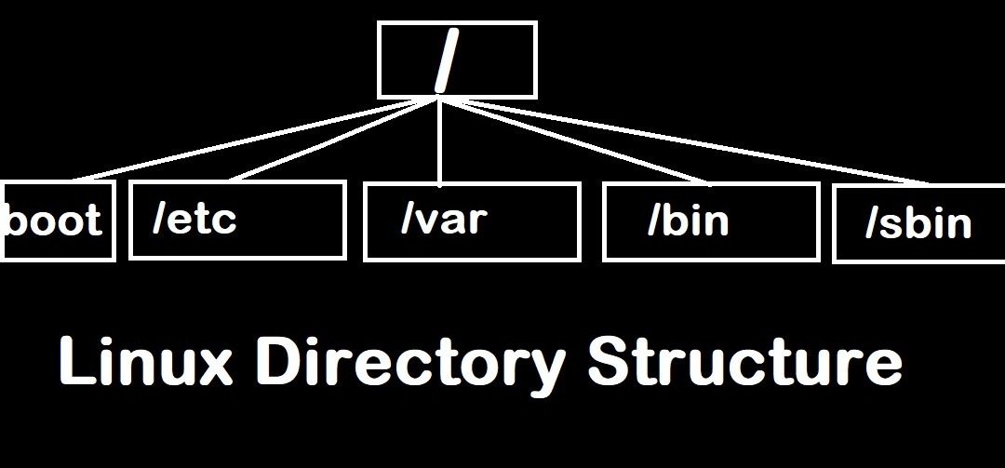
Absolute Path vs Relative Path in Linux
In Linux, a path is used to specify the location of a file or directory in the file system. There are two main types of paths used to access files: Absolute Path and Relative Path.
Absolute Path
An absolute path is the complete path of a file or directory starting from the root directory (/). It always begins with / and shows the exact location of the file in the system.
Command:
/home/naveen/documents/file.txt
This path clearly shows that the file file.txt is located inside the documents directory, which is inside the naveen home directory.
Relative Path
A relative path specifies the location of a file or directory relative to the current working directory. It does not start with /.
Command:
documents/file.txt
This means the file is located inside the documents folder in the current directory.
Special Relative Path Symbols
Linux uses special symbols for navigation:
. → Current directory
.. → Parent directory
~ → Home directory

